A Binned-Profile Approach to the Color Blending Problem

in Transparent See-Through Displays

Author 1*

Organization or School

Abstract

See-through displays allow users to view both digital content and physical objects at once. In such displays, light coming from background objects mixes with the light originated in the display, causing what is known as the color blending problem. Color blending is an important issue for the wider adoption of see-through displays and AR in general as it affect the legibility and color encodings of digital content, with a negative impact on the general usability of such displays. Color preservation aims at reducing the impact of color blending by finding an alternative color which, once blended with the background, would result in the original color. At the heart of color preservation is the capacity to predict how digital and background colors blend for a particular display.

In this paper we propose the binned-profile model for color prediction and preservation in see-through displays. The binned-profile model is based on the observations that each display renders colors differently and that background colors are changed by the display medium before blending. For a given display the model uses a colorimetric profile of how such display shows colors; with colors binned to a small set of “noticeably different” colors. We validate our model by measuring the accuracy of the predictions against other prediction models (direct model and chromatic adaptation transformations). Then, we introduce a color correction algorithm and measure the accuracy of the corrections. We investigated our approach with an extensive set of digital and background colors and different hardware configurations (projector-based and OLED displays). Finally, we elaborate on the usability and design implications of our approach for color preservation.

**Keywords**: Color Blending, Optical See-through Displays, Color Binning, Color Correction, Color Perception.

**Index Terms**: H.5 [Information Interfaces and Presentation]: H.5.1: Multimedia Information Systems — Artificial, Augmented, and Virtual Realities; H.5.2: User Interfaces — Ergonomics, Evaluation / Methodology, Screen Design, Style Guides

# Introduction

Optical see-through displays allow users to view both digital content and physical objects at once. They come in multiple form factors (e.g. head mounted displays or projection-based) and are used in augmented reality (AR) as a way to enhance the real world with digital information. Although other technologies can also be used for AR (e.g. video see-through displays), optical see-through displays have the advantage of letting users see the real world with their own eyes, without reducing its fidelity and preserving properties like lighting, texture, color, age and wear. Researchers investigate optical see-through displays for a wide range of applications including medical, maintenance, education and training (see [1][3][6] for a comprehensive list of applications); with a few consumer electronics have started to adopt them [8][Android glasses]. We can expect wider adoption of such technologies with the introduction of novel mobile AR platforms like Google Glass [], and the continuous development of transparent LCD (Samsung NL22B [[link](http://www.samsung.com/us/business/commercial-display-solutions/LH22NLBVLVC/ZA)], Eyevis [[link](http://www.eyevis.de/index.php?article_id=163&clang=1)], RichTech [[link](http://www.richtechsystem.com/html/transparent-video-showcase.html)]) and OLED displays (Futaba Corporation [[link](http://www.oled-info.com/futabas-oled-road-map-amoleds-2014-transparent-and-flexible-oleds-cars-2015)], Fujitsu [[link](http://www.fujitsu.com/be/Images/Workplace_of_the_Future.pdf)], Winstar [[link](http://www.winstar.com.tw/newspaper_ov.php?lang=en&ID=153)]).

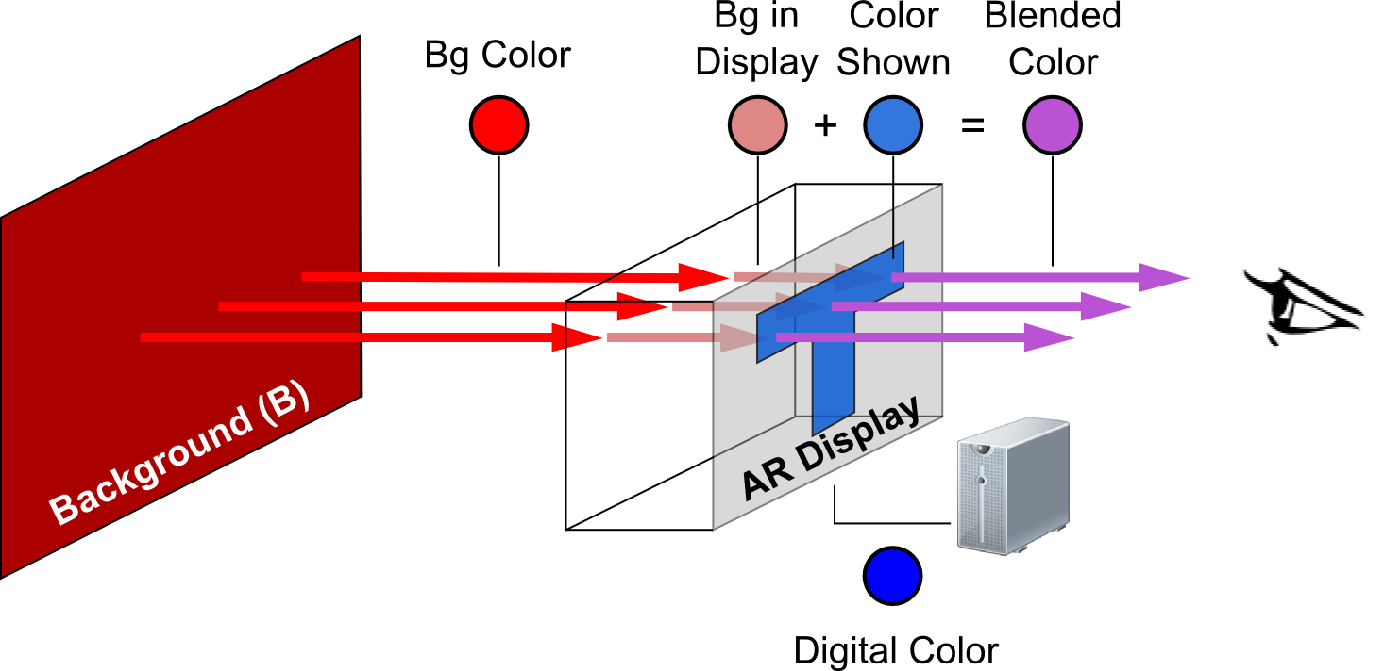

Figure 1. Color blending including the screen distortions for background and digital colors.

An important aspect of optical see-through displays is that background light coming from real-world object mixes with the light emitted by the display, something that has been described as color blending [1]. Color blending is an important issue as it can affect the legibility and color-encoding of digital information, and compromise the general usability of such devices. Despite being a widely acknowledge problem for the adoption of optical see-through displays and general AR applications, little research exists on how to preserve digital colors exposed to color blending. To preserve a digital color a system should find an alternative digital color which, upon blending with such background, comes closest to the desired digital color. Existing solutions include blocking background light, and iterative correction and measuring of the digital content. PROBLEMS WITH THIS APPROACH.

LEAVE 0.5 INCH SPACE AT BOTTOM OF LEFT COLUMN ON FIRST PAGE FOR COPYRIGHT BLOCK

* email address

An effective approach to preserve digital color in see-through displays relies on its *prediction* accuracy, i.e. the capacity to estimate the blend resulting from a given background and digital colors and for a particular display. In this paper we argue that high prediction accuracy requires taking into account two distortions introduced by the display and shown in Figure 1: (1) the way a particular display renders colors, and (2) the effect of the display media on the background color. To address the first distortion we propose the binned profile prediction model: a model that divides the continuous universe of colors into discrete and finite bins and measures how the display actually renders each bin. To address the second distortion we measure the background color only after passing through the display. We compared our model with other approaches to the *direct model*, the *chromatic adaptation transformation* (*CAT) model*. The direct model ignores the effect of the display on the digital colors; the CAT model uses known transformation matrices to determine the way a display shows particular colors.

We used a colorimeter to measure the accuracy of the different prediction models on three transparent see-through displays. Results showed that prediction with the binned-profiled model and background display distortion outperforms other combinations. We compared the accuracy of color preservation using the binned-profile model against using the direct model, with and without the background display distortion. Results showed our model outperforms the direct model correcting a wider range of colors and with higher accuracy.

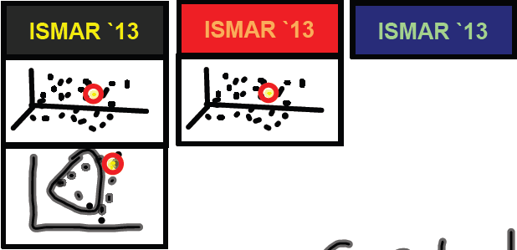

Figure 2. Examples of color blending

This paper contributes to the field of augmented reality in several ways: 1) we propose a novel approach to color prediction and preservation for optical-see through displays; 2) we validate our approach against other possible solutions; 3) we discuss the implications of color blending for situations where color preservation is not possible or contrast preservation is preferred; and finally 4) we discuss the challenges associated to incorporating our algorithm into everyday optical see-through display platforms.

# Background

Color blending is the phenomenon where background light coming from real-world object mixes with the light emitted by the display and changes it. Figure 2-top shows examples of color blending for a yellow text over three different background conditions: no background (black), red and blue. Figure 2-bottom shows the corresponding shift in color: the yellow text shifts toward orange when the background is red, while the green text shifts toward green when the background is blue. Field studies of AR applications with optical see-through displays reveal that the clarity and legibility of digital colors are affected by such changes in normal outdoors conditions; i.e. the colors in text and icons are altered (change in hue) or washed out (de-saturation) [Pingel and Clarke 2005]. Such changes affect the user interface and can render it useless: e.g. text might turn unreadable when washed out, or color encoded information such as red warning icons might lose their visual meaning.

Gabbard et al. studied such color changes in optical see-through displays [8] by building an experimental test-bed and examining foreground (27 colors on the edge of the RBG gamut) and background colors (6 common outdoor colors – foliage, brick, sidewalk, pavement, white and no background) of different lighting level and hues. His results showed how light background colors affect all other colors by pulling them towards white; while background colors of different hues pull all colors toward them. They defined the color blended and perceived by a user (CP) as a function of the light source (L1), the reflectance (RF) of background object (B), the light emitted by the display (L3), the interaction of both L1 and L3 in the display (ARD), and the human perception (HP). Equation 1 describes the interactions:

(1)

Our goal in this paper is to offer a solution to the color blending problem by means of colorimetric compensation: carefully selecting the color shown by the display so that the resulting blend comes close to the color originally intended. At the core of color compensation is the capacity to estimate how two colors blend; more specifically, how a color showed by the display blends with a particular background color. To do so we take equation 1 as our starting point and unravel the interaction of colors on the display (ARD) to account for two externally observable distortions. The first distortion is due by the fact that each display represents digital colors differently, and that it is such representation the one to consider when estimating color blending. Figure 3-left shows the color red (#FF0000) as displayed by different screens. Figure 1 illustrates this distortion as the difference in hues between the “digital color” (DC) and the “color shown” (CS): for a given digital color, different displays produce light of different hues. The second distortion is due to the display medium changing the background color before blending (BCD). Figure 3-right shows the foliage color as seen through different screens. Figure 1 illustrates this distortion as the difference in hues between the “bg color” and the “bg in display” color. In our formulation we simplify the light and reflectance of the background (the RF(L1,B) component of equation 1) into the single entity “background color” (BC). Moreover, we leave the influence of human perception of colors for our future work. Thus, we formulate color blending as follows:

(2)

Key to our understanding of color blending is the characteri-zation of the fdDC and fdBC functions. The fdDC function describes the way a particular display shows a given digital color. The fdBC function describes the way a background color is altered by the display medium.

To explore the nature of these functions we use three different optical see-through displays, a standard LCD display for background colors, and a colorimeter for color measurements (see section 4 for a detailed description of our experimental test-bed). To examine the colors in the background display, the digital colors on optical see-through displays and the resulting color blends we used the notations of the *Commision Internationale de l’Éclairage* (CIE) color model. We use the CIE 1931 XYZ color space for color measurement and addition required by equation 2. However the XYZ color space resembles the working of the human visual system which is more sensitive to colors in the blue or green hours. Therefore, we used the CIE 1976 Lab color space, a perceptually uniform color space, to calculate the perceptual difference between colors; e.g. the distance between a color and its shift when blended, or the distance between a blend prediction and the measured blend.

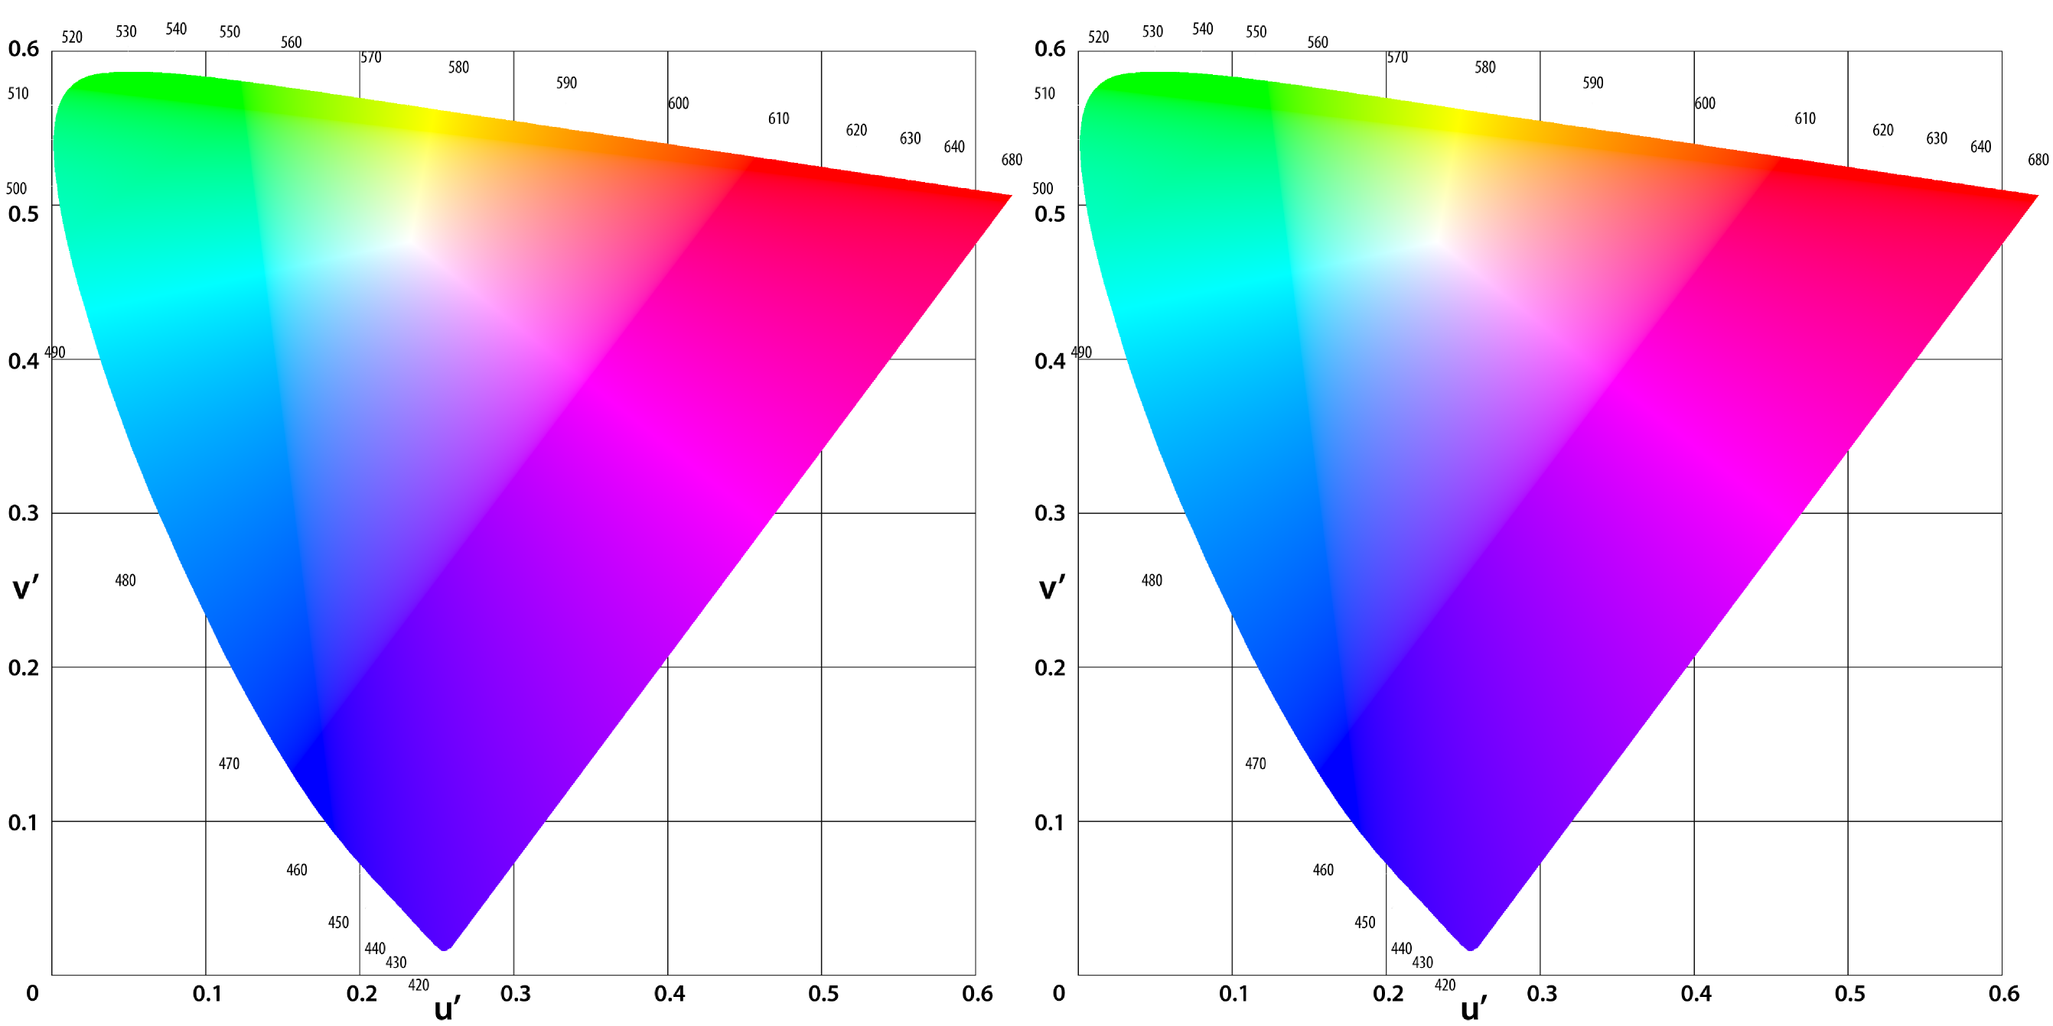

Figure 3. Left: The digital color #FF0000 and as displayed by different optical see-through displays. Right: The folieage color, and as it is seen through different optical see-through displays.

# Related Work

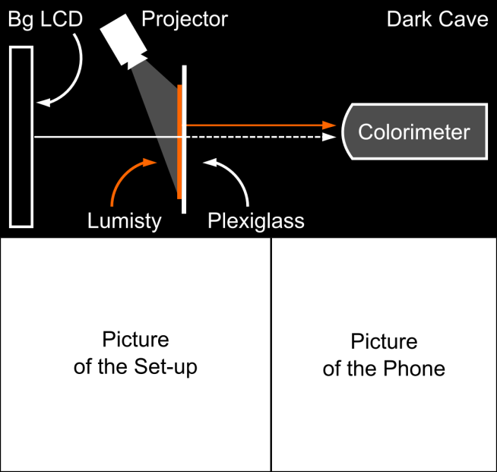

Figure 4. Experimental test-bed

Researchers have long discussed color blending as a significant perceptual challenge for the field of AR [17] especially in outdoor environments. Field studies of AR applications highlight that such inability so see the display clearly is worse with bright sunlight and with the sun lower in the sky [13]. In order to improve the display visibility users resort to strategies like looking for a dark spot (dark surface or shadow) or placing a hand in front of the display. Both strategies require users to switch context between their activity and the display and often missing important information. Strategies like these inspired researchers to investigate automatic ways to improve display clarity. A simple approach is to dynamically increase the intensity of the digital content (mentioned in [15]), however such solution is not always efficient [13]. Leykin and Tuceryan capture the field of view of the user and classify this image into zones where digital text would be readable or unreadable [18]. In a similar fashion, Tanaka et al. developed a layout system that relocates digital content to the darker areas of the display [25] taking into account restrictions like ordering of the components.

Color blending is also an important factor affecting the effective occlusion of physical objects by digital content; a feature particularly useful when the real environment is enhanced with 3D virtual objects that are intended to look real, such as in architectonical previewing. Without effective occlusion, the virtual object is perceived as translucent and unreal [5] and can confuse users [23]. Solving the occlusion problem keeps digital content from being affected by the physical objects in the background, thus solving the color blending problem. The main approach to solving occlusion has been to stop the light coming from the background by enhancing head-mounted displays with light blocking devices such as a transparent LCD [14][16][27] or spatial light modulators (SLM) [5]. In this approach a black/white depth mask of the scene is generated with the black pixels covering the area where digital content is not to mix with the background light. Therefore, digital colors projected on the black areas as seen in their original hue and lightness. Another solution is to control the illumination of the physical objects in a way that areas behind digital content remain in the dark. Noda et al. explored this approach by constraining digital objects into a dark room [22], while Bimber and Frölich implement it via occlusion shadows in a virtual showcase [2]. Finally, occlusion support has also been achieved by placing in spatial AR by placing the parts of the optical system behind the augmented object, such as Inami et al.’s usage of retro-reflective material as optical camouflage [12].

Our approach differs from the existing solutions as we aim not to change the location of user interface elements and not to add new hardware components to the see-through display; rather we seek to manipulate the color shown by the see-through display; an approach known as colorimetric compensation or color correction.

The field of projector-based spatial AR studied color correction as a way to enable projections on non-white or textured surfaces. Nayar et al. proposed a camera-based radiometric calibration model to compute the relation between the digital image and the projection on a textured surface **Error! Reference source not found.**. Their approach requires a calibration phase where known images are projected on the projection surface and the resulting blended images are processed to obtain compensation matrixes. The calibration phase is repeated for each new projection surface or when lighting conditions change. Bimber et al.extended the range of projectable color by using a transparent film and multiple projectors taking into account the reflectance and absorption of the digital color by the projection surface **Error! Reference source not found.**. Grossberg et al. extended the radiometric model to include ambient light **Error! Reference source not found.**. While these works deals primarily in device dependent RGB space, higher correction accuracy is achieved by working on the device independent CIE XYZ color space [Ashdown, Menk]. Weiland et al. studied colorimetric compensation in see-through displays, and proposed a subtraction compensation model which is based on both color differences and the human eyes adaptive range. This model limits the amount of correction introduced by the compensation algorithm, as a way to guaranty that digital content is shown even when light backgrounds. Their results shows good compensation results although the approach is limited to rather static digital content and background settings.

In this paper we continue this line of work with see-through displays but aim at situations where the background is not static and illumination conditions continuously change. Our work uses background subtraction with special considerations for the actual nature of foreground and background colors. We proposed the binned-profile model, an approach which uses a measured display profile for foreground colors, and considers background colors as seen through the display. Further we perform our calculations using the device independent CIE XYZ and CIE LAB color spaces. Finally, we extend our study to both projector-based and transparent OLED displays.

# Experimental Test-Bed

We designed and built an experimental test-bed to generate background colors at different lighting conditions, show colors on multiple see-through displays, and measure the resulting color blending (Figure 4).

To generate different backgrounds we chose an XXXX LCD display calibrated at the standard white point of D65, a white that accurately reproduces the color spectrum as it exists outdoors. This approach to generating the background color is restricted by the color gamut of the LCD. Our test-bed design takes distance from previous systems [8] which prioritize the capacity to obtain background colors as seem in everyday outdoor settings; our design prioritizes the capacity to automatically produce a wide variety of colors. For our experiments we used background colors from the Macbeth color chart, as they mimic those colors of everyday natural objects like skin color, foliage and flowers. Figure 6A shows the difference between the theoretical background colors and the ones produced and captured in our test-bed.

Our test-bed works with three see-through displays: two projector-based and one transparent OLED. The projector-based displays use 3 mm thick transparent acrylic surface covered with a Lumisty MFY 2555 film ([http://www.lumistyfilm.com](http://www.lumistyfilm.com/)) and one of two projectors at 40 degrees. The first projector is an Epson 1705 at 2200 lumens, hereafter called the p2200 display. The second projector is an Epson VS35ow at 3700 lumens, hereafter called the p3700 display. For the transparent OLED display we used a Lenovo S800 phone [10] which has a 240x320 transparent OLED display at 167 ppi, hereafter called the T-OLED display. The T-OLED display is covered in acrylic and with a total 9 mm thickness. The test-bed has a holder for the displays at 20 cm in front of the background LCD.

To collect data we used a Konica Minolta CS-200 luminance and color meter at a 0.2 degrees angle (standard observer angle). For both p2200 and p3700 displays we measured the XYZ white points of the Lumisty surface at 5 different points: one near the each of the display’s four corners and one in the center. For both projectors all measurements of the white point remained the same. Based on these results we located the colorimeter at 20 cm away from the see-through and at the center of the display. The colorimeter measures colors in the XYZ color space and we converted these values into a normalized LAB space using the appropriate white point for each case. After calibrating the background LCD to the D65 white point (measured at 0.9504, 1, 1.0888) we measured two combinations of the white points per display:

1. See-through showing white and bg LCD turned off.
2. Both see-through and bg LCD showing white.

We took the average out of 100 measures per combination. Table 1 presents the white points of the different see-through displays.

|  |  |  |  |  |
| --- | --- | --- | --- | --- |
|  | **Display** | **p2200** | **p3700** | **S800** |
| **No BG** | X  Y  Z | 0.2655720  0.282182  0.481033 | 0.9504  1  1.0888 | 0.383264  0.395001  0.369982 |
| **White** | X  Y  Z | 0.9504  0.990041  1.0888 | 0.9504  1  1.0888 | 0.724775  0.759896  0.727336 |

Table 1: White points for all three see-through displays.

All displays and colorimeter are connected to the same controlling computer and are kept from any outside light by an enclosure (represented in Figure 4 as the dark cave).

# Color Prediction

In order to build an accurate color preservation system, it is necessary to have accurate estimations of how the resulting blend for a give pair of background and foreground colors. Providing such estimation requires unveiling the fdDC and fdBC distortion functions of equation 2.

In this paper we propose a model of the fdDC distortion function called the binned-profile model (BP). The BP model divides the RGB color space (over 16 million colors) into a smaller set of perceptually different bins (8376 bins). To create the bins we divided the CIE LAB color space into boxes of 5×5×5 – a method proposed by Heer and Stone [11] which guarantees all colors inside the box are within one noticeable difference; i.e. they are perceived as the same color by a human observer [19]. Figure 5 shows the actual CIELAB color space and the binned result. Then, we measured how each bin is shown by each of our three display devices. We turned off the background LCD and measured the display reproduction of the whole binned RBG color space (8376 colors were shown with no background) for each of our displays. Each color was captured using the colorimeter and the captured XYZ values where transferred into the CIE LAB color space by using the reference white points given in the Table 1 (top row). Based on these measurements we created the look-up table for each display. Figure 5C-E presents the profile for each display with the p3700 matching the binned space almost perfectly (C), and considerable reduction of color capacity for the p2200 (D) and T_OLED displays (E).

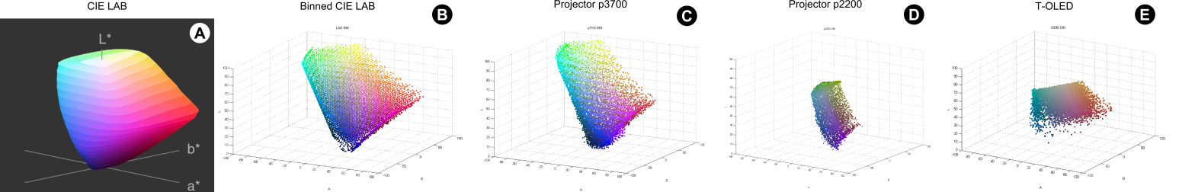

Figure 5. (A) CIELAB color space, (B) the binned space, and the binned profile for the (C) p3700 and (D) p2200 projector-based displays, and for (E) for the T-OLED display.

When predicting how a digital color blends with a particular background, the model determines the bin of the digital color and uses the display’s lookup table to know how such bin is actually shown (Color Shown in Figure 1). The system predicts how the two colors blend by adding this color to the background. Listing 1 describes this process in details.

BP_prediction(display, foreground, background)

binned_foreground = findBin(foreground)

display_foreground = lookup(display , binned_foreground)

prediction = addXYZ(display_foreground, background)

**return** prediction

Listing 1. Binned-Profile prediction algorithm

We compare the prediction accuracy of our model against the direct model (DM) and three chromatic adaptation transformation models (CAT). Listing 2 presents the direct model, where the digital color is simply added to the background.

DM_prediction(foreground, background)

prediction = addXYZ(foreground, background)

**return** prediction

Listing 2. Direct model prediction algorithm

Chromatic adaptation transformation (CAT) is an established method to estimate the actual colors a display can reproduce based on the brightest white it can emit. In other words, CAT could potentially account for the fdDC distortion function of see-through displays. CAT is based on matrices and researchers have proposed CAT models which rely on different matrices. We chose three popular CAT models for our investigations on color blending: Bradford [24], Von Kries [24], and XYZ Scaling [7]. We selected those models due to their popularity in the literature and as a representative set of their kind. Listing 3 presents how we used CAT models for our blending predictions; we transformed the foreground color using the respective CAT matrix before adding it to the background.

CAT_prediction(CATmatrix, foreground, background)

cat_foreground = foreground × CATmatrix

prediction = addXYZ(cat_foreground, background)

**return** prediction

Listing 3. CAT model prediction algorithm

As in existing AR systems [26][4][15] we expect a system with color correction to use a camera to capture the background and map its colors to particular pixels in the display as input for the correction algorithm. Although the fidelity of such camera-based color capture is beyond the scope of the present paper [], we work under the assumption a camera could capture the real nature of background colors. To account for the second distortion, i.e. the impact of the display medium on the background color described by the fdBC distortion function, we compare two configurations of such camera: in *front* of the display and *behind* the display. Locating the camera in front of the display implies that the effect of the display medium on the background color is negligible for the overall prediction and correction, so that . Locating the camera behind the display assumes there is indeed an impact, and that such impact can be measured before blending occurs (see *Bg Color in Display* in Figure 1). In our experimental set-up we compare the impact of both configurations on color blending prediction.

We considered 23 of the ColorChecker Color Rendition Chart [20] at D65, a representative set of naturally occurring colors (the 24th ColorChecker color is outside the gamut). We measured the actual (a,b) coordinates of the colors as shown by the background LCD. These values correspond to the *front* background configuration (see Figure 6A). We also measured how each back-ground color would be seen through the see-through displays (see Figure 6B-C). These values correspond to the *behind* background configuration for each display. Figure 6A-C shows our measurements for both background configurations. For the background LCD there is a displacement in *a* and *b,* however the *L* remains stable with an average change of 1.56 units in LAB; this means the background LCD displays the ColorChecker colors in a way that resembles how they are normally seem in nature. For the see-through displays the data shows displacement in *a* and *b*, but also a considerable reduction of *L*; this is due to the display material absorbing some of the light from the background. Note the significant impact of the T-OLED display on all axes.

## Data Collection

In order to access the prediction accuracy of the BP model and compare with the other models (CM and CATs) under the two background configurations (*front* and *behind*), we collected a large set of actual color blends. We used the 23 ColorChecker colors for backgrounds and 838 random foreground colors (10% of the size of the bin). We measured the resulting blending for each of our three displays capturing a total of 23×838 = 19.274 measurements per display and 19.274×3 = 57.822 measurements in total. We converted the blending measurements into CIE LAB using the white points from table 1. At the same time we predicted the resulting color blend according to the algorithms in listings 1-3 for each combination of prediction model (5), background configuration (2) and display (3). We obtained 5×2 = 10 predictions per blending, 5×2×23×838 = 192.740 predictions per display, to a total of 192.740×3 = 570.822.

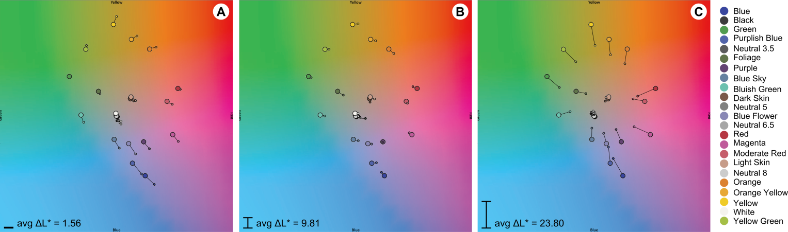

Figure 6. ColorChecker bg color set as (A) shown by the background LCD, (B) as seen through the p2200 and p3700 displays, and (C) as seen through the T-OLED display. The bigger circles represent the original color, the smaller circle how it is measured in each condition.

We computed the accuracy of the predictions by calculating the Euclidian distance in CIA LAB color space between each prediction and the actual measurement.

## Results

Given the wealth of data we collected we first introduce different visualizations we use for our data analysis. Figure 7 shows the prediction results for a random sample set on the foliage background color, on the p3700 display, with the front background configuration, using the direct model. Figure 7A shows the prediction accuracy as a 3D shape in LAB space with more accurate predictions in light blue and less accurate ones in dark; the location of the points corresponds to the profile of the display. This 3D figure is instrumental in understanding which color areas are better predicted than others. However, it’s hard to draw general conclusions about the prediction accuracy. Figure 7B shows a histogram of the same data points sorted by accuracy. More accurate predictions piled up on the left near to zero, while less accurate predictions spread to the right. Figure 7C is a top view of this histogram with zero close to the bottom of the graph and color intensity representing the height of the histogram. We use these vertical histograms to analyze the results of our prediction study. Figure 8 presents different colors that differ from the first one linearly and the magnitude of this difference in Euclidian distances and JNDs. For example, the best prediction in Figure 7 is at an Euclician distance of XX.XX (XX.XX JND), similar to distance to the first square in Figure 8; while the worst prediction is at an Euclician distance of XX.XX (XX.XX JND), similar to the distance to the last square (i.e. the estimation was that much off).

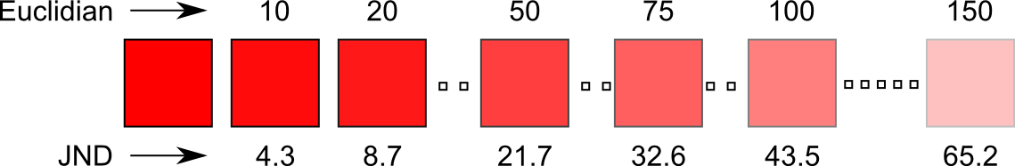

Figure 7. Examples of Euclidian distances and their corresponding just-noticeable difference.

Figure 9 summarizes the results for our prediction study using vertical histograms. A visual inspection of the results shows that for all conditions the CAT models performed worst, with a high spread in the accuracy and average far from optimal (in the case of the p3700 display, the CAT models all perform the same due to the fact that the white point of this display is exactly D65). Thus we exclude the CAT models from the rest of this analysis.

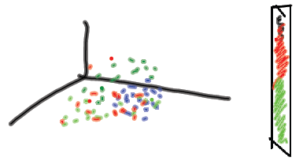

Figure 8. Single prediction result

For the p2200 display the BP model performed best in each background configuration (*front*: 10.01 avg. dist., 2.74 std. dev. – *behind*: 4.96 avg. dist., 2.40 std. dev.). The DM model also presented, even if subtler, a different between background configurations (*front*: 22.81 avg. dist., 12.31 std. dev. – *behind*: 22.16 avg. dist., 15.08 std. dev.). We observe a similar pattern for the p3700 display where the BP model has higher prediction accuracy for both background configurations (*front*: 10.28 avg. dist., 5.39 std. dev. – *behind*: 2.77 avg. dist., 1.9 std. dev.) than the DM model (*front*: 17.5 avg. dist., 7.27 std. dev. – *behind*: 13.67 avg. dist., 6.43 std. dev.). Finally, THE T-OLED…

Overall, results show the binned-profile model consistently outperforms the other prediction models we tested across all 23 background colors; with predictions ranging between 1 and 4 JNDs. Moreover, this high accuracy exists for both the *front* and *behind* camera configurations, stressing out the importance of the first display distortion (how the display repre-sents digital color) as the dominant factor for color prediction. More importantly, our results highlight the limitations of the direct model (ignoring the display distortion) and the inadequacy of any of the three CAT models we tested.

# Color Preservation

Color correction is based on basic rules of color physics where the two color values can be added to from the third. As shown in many previous works in projection based spatial AR[16][4][8] the backgrounds effect on the digital content can be neutralized by counter balancing the digital color with a negative equivalent of the background. As shown in [Ashdown, Menk] with these operations did in device independent color space archives higher correction accuracy. Based on the results from our prediction models results the binned profile model which considers the effect of the screen on the background was found to be most accurate. We decided to do the color correct based on this highly precise model for correction.

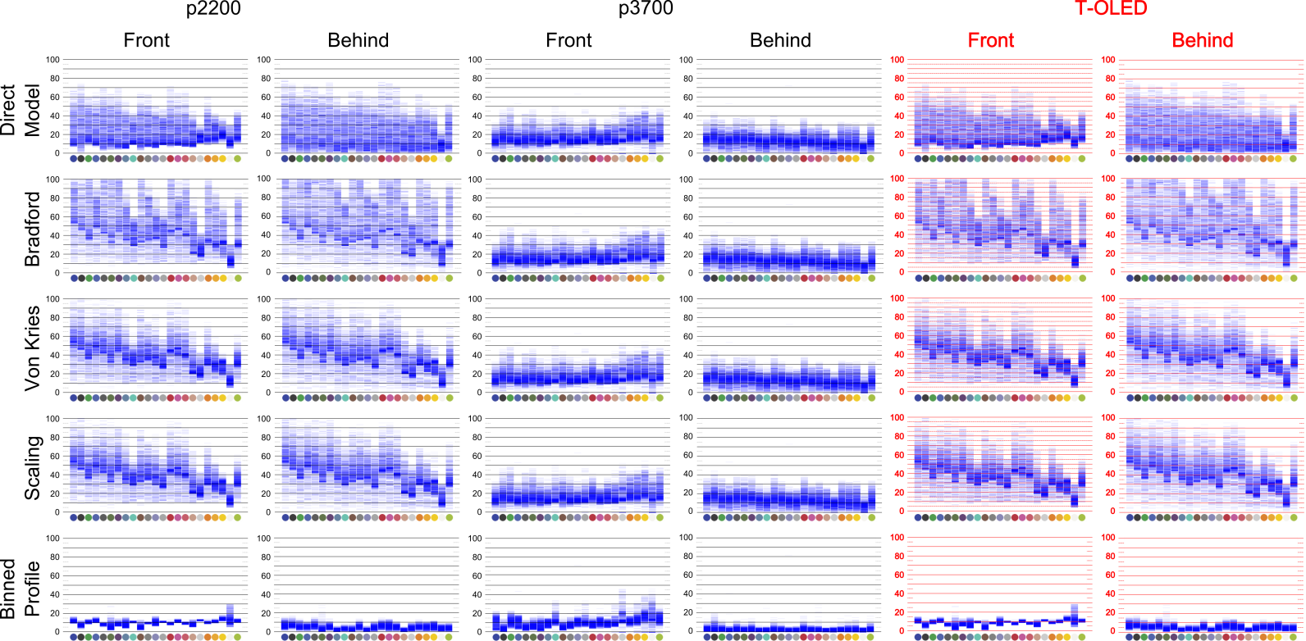

Figure 9. Prediction results

The Binned profile based correction is built on the capacity of the system to predict how the color changes accurately. The correction algorithm makes use of the linear addition present in color. To preserve we try to counter balance the background’s color in the digital color. Such that when the corrected color is rendered on the screen, it turns into the correct foreground color on blending.

Although the previous work have used direct model as the solution to correct color [Weiland] or have suggested as a possible approach to correct color[gabbard]. As the results from our study on model precisions accuracy shows how the screen changes the background and how the display shows the colors have a very high influence on the color blending. Based on our results we build bin profile model based algorithm to correct colors taking these distortions into account.

Correction algorithm is given in listing 4 works as follows, any given digital color is first mapper with its equivalent displayed color using bin profile, and then linear color subtraction is applied on XYZ values of the displayed color to find the counter balanced color. This counter balanced color is again matched with bin to find the color to be displayed on the display. As we are working with only 8000 odd colors, to make sure to choose the right corrected color , we make use of the bin predication which was proven to be accurate to choose a color. Such that the color chosen will produce best possible result on blending with the background.

BP_preservation(display, foreground, background)

binned_foreground = findBin(foreground)

display_foreground = lookup(display , binned_foreground)

accuracy = INFINITY

**foreach** color **in** display

prediction = addXYZ(color, background)

tmp_accuracy = distance(prediction, display_foreground)

**if** tmp_accuracy < accuracy

accuracy = tmp_accuracy

color_to_show = color

**return** color_to_show

Listing 4. Binned-Profile color preservation algorithm

## Data Collection

## Results

# Discussion

Colors that can be corrected regardless of the background

Camera-based color correction

Closed look approaches might not be possible in HMDs because of the human face configuration (the camera would have to be located where the eye is located to capture both the screen content and the background). Therefore a *front* approach could also be used with similarly good results.

For spatial AR (where the location is known) a 3D model of the background could exist and projection of the lighting for a given perspective could be calculated real time before correction.

# Conclusions

We described the color blending problem in terms of two color distortions introduced by the see-through display medium: a distortion in the way the display represents colors and the distortion on the background color before it blends with the color on the display.

We introduced the binned-profile model for color prediction and correction where a display profile is built based on colorimetric measurements and used as a look-up table for color calculations.

Based on an extensive collection of colors we demonstrate the accuracy of the binned-profile approach for predicting color blending for a limited set of background colors in three different see-through displays.

References

1. Azuma, R., Baillot, Y., Behringer, R., Feiner, S., Julier, S., and MacIntyre, B. 2001. Recent Advances in Augmented Reality. IEEE Comput. Graph. Appl. 21, 6.
2. Bimber, O., and Fröhlich, B. 2002. Occlusion Shadows: Using Projected Light to Generate Realistic Occlusion Effects for View-Dependent Optical See-Through Displays. In Proc. ISMAR '02.
3. Bimber, O. and Raskar, R. 2005. Spatial Augmented Reality: Merging Real and Virtual Worlds. A. K. Peters, Ltd., Natick, USA.
4. Bimber, O., Emmerling, A., and Klemmer. T. Embedded Entertain-ment with Smart Projectors. IEEE Computer, 38(1):48–55, 2005.
5. Cakmakci, O., Ha, Y., and Rolland, J.P. 2004. A Compact Optical See-Through Head-Worn Display with Occlusion Support. In Proc. ISMAR '04. IEEE.
6. Carmigniani, J., Furht, B., Anisetti, M., Ceravolo, P., Damiani, E., and Ivkovic, M. 2011. Augmented reality technologies, systems and applications. Multimedia Tools Appl. 51, 1.
7. Chromatic Adaptation. (2013, April 23). Chromatic Adaptation. (2009) [Website]. Retrived from http://www.brucelindbloom. com/index.html?Eqn_ChromAdapt.html
8. Gabbard, J.L., Swan, J.E., Zedlitz, J., and Winchester, W.W. 2010. More than meets the eye: An engineering study to empirically examine the blending of real and virtual color spaces. In Proc. VR '10. IEEE.
9. Grossberg, M.D., Peri, H., Nayar, S.K., and Belhumeur, P.N. Making one object look like another: controlling appearance using a projector-camera system. 2004. In Proc. CVPR 2004.
10. GSM arena. (2013, March 19). Lenovo S800 – Full phone specifications. (2011) [Website]. Retrieved from <http://www.gsmarena.com/lenovo_s800-4862.php>.
11. Heer, J., and Stone, M. 2012. Color naming models for color selection, image editing and palette design. In Proc. CHI '12. ACM.
12. Inami, M., Kawakami, N., Sekiguchi, D., Yanagida, Y., Maeda, T., and Tachi, S. 2000. Visuo-Haptic Display Using Head-Mounted Projector. In Proc. VR '00. IEEE.
13. Kerr, S.J., Rice, M.D., Teo, Y., Wan, M., Cheong, Y.L., Ng, J., Ng-Thamrin, L., Thura-Myo, T., and Wren, D. 2011. Wearable mobile augmented reality: evaluating outdoor user experience. In Proc. VRCAI '11. ACM.
14. Kiyokawa, K., Billinghurst, M., Campbell, B., and Woods, E. 2003. An Occlusion-Capable Optical See-through Head Mount Display for Supporting Co-located Collaboration. In Proc. ISMAR '03.
15. Kiyokawa, K., Kurata, Y., and Ohno, H. An optical see-through display for mutual occlusion with a real-time stereovision system, Computers & Graphics, Volume 25, Issue 5, October 2001, Pages 765-779.
16. Kiyokawa, K., Ohno, H., and Kurata, Y. 2002. Occlusive optical see-through displays in a collaborative setup. In Proc. SIGGRAPH '02. ACM.
17. Kruijff, E.; Swan, J.E.; Feiner, S., 2010. Perceptual issues in augmented reality revisited. In Proc. ISMAR’10. IEEE.
18. Leykin, A. and Tuceryan, M. 2004. Automatic Determination of Text Readability over Textured Backgrounds for Augmented Reality Systems. In Proc. ISMAR '04. IEEE.
19. Mahy, M., Eyckden, L.V. and Oosterlinck, A. Evaluation of uniform color spaces developed after the adoption of CIELAB and CIELUV. Color Res. Appl., vol. 19, no. 2, pp. 105–121, Apr. 1994.
20. McCamy, C. S., Marcus, H., and Davidson, J. G. (1976). "A Color-Rendition Chart". Journal of Applied Photographic Engineering 2(3). 95–99.
21. Nayar, S. K., Peri, H., Grossberg, M. D., and B. P. N. A projection system with radiometric compensation for screen imperfections. In Proc. of International Workshop on Projector-Camera Systems, 2003.
22. Noda, S., Ban, Y., Sato, K., and Chihara, K. 1999. An Optical See-Through Mixed Reality Display with Realtime Rangefinder and an Active Pattern Light Source. Transactions of the Virtual Reality Society of Japan, 4(4), 665-670.
23. Sekuler, A.B. and Palmer. S.E. "Perception of partly occluded objects: A microgenetic analysis." Journal of Experimental Psychology: General 121.1 (1992): 95.
24. Susstrunk, S. E., Holm, J. M., & Finlayson, G. D. (2000, December). Chromatic adaptation performance of different RGB sensors. In Photonics West 2001-Electronic Imaging (pp. 172-183). International Society for Optics and Photonics.
25. Tanaka, K., Kishino, Y., Miyamae, M., Terada, T., and Nishio, S. 2008. An information layout method for an optical see-through head mounted display focusing on the viewability. In Proc. ISMAR '08. IEEE.
26. Weiland, C., Braun, A.K., and Heiden, W. 2009. Colorimetric and Photometric Compensation for Optical See-Through Displays. In Proc. UAHCI '09. Springer-Verlag.
27. Zhou, Y., Ma, J.T., Hao, Q., Wang, H., and Liu, X.P. 2007. A novel optical see-through head-mounted display with occlusion and intensity matching support. In Proc. Edutainment'07. Springer-Verlag, Berlin, Heidelberg, 56-62.